hw3-336.R

ethan

2020-12-04

#5.8  
#ethan  
da1=scan("NOAAGlobalTemp.gridded.v4.0.1.201711.asc.gz")  
#From Jan 1880 to Jan 2017  
length(da1)

## [1] 4293070

#[1] 4267130  
da1[1:3]

## [1] 1.0 1880.0 -999.9

#[1] 1.0 1880.0 -999.9 #means mon, year, temp  
#data in 72 rows (2.5, ..., 357.5) and   
#data in 36 columns (-87.5, ..., 87.5)  
tm1=seq(1,4267129, by=2594)  
tm2=seq(2,4267130, by=2594)  
length(tm1)

## [1] 1645

length(tm2)

## [1] 1645

mm1=da1[tm1] #Extract months  
yy1=da1[tm2] #Extract years  
head(mm1)

## [1] 1 2 3 4 5 6

head(yy1)

## [1] 1880 1880 1880 1880 1880 1880

length(mm1)

## [1] 1645

length(yy1)

## [1] 1645

rw1<-paste(yy1, sep="-", mm1) #Combine YYYY with MM  
head(tm1)

## [1] 1 2595 5189 7783 10377 12971

head(tm2)

## [1] 2 2596 5190 7784 10378 12972

tm3=cbind(tm1,tm2)  
tm4=as.vector(t(tm3))  
head(tm4)

## [1] 1 2 2595 2596 5189 5190

#[1] 1 2 2595 2596 5189 5190  
da2<-da1[-tm4] #Remote the months and years data from the scanned data  
length(da2)/(36*72)

## [1] 1655.008

#[1] 1645 #months, 137 yrs 1 mon: Jan 1880-Jan 2017  
da3<-matrix(da2,ncol=1645) #Generate the space-time data

## Warning in matrix(da2, ncol = 1645): data length [4289780] is not a sub-multiple  
## or multiple of the number of rows [2608]

#2592 (=36*72) rows and 1645 months (=137 yrs 1 mon)  
dim(da3)

## [1] 2608 1645

#[1] 2592 1645  
  
#Put space-time coordinates in the space-time data da3  
colnames(da3)<-rw1  
lat1=seq(-87.5, 87.5, length=36)  
lon1=seq(2.5, 357.5, length=72)  
LAT=rep(lat1, each=72)  
LON=rep(lon1,36)  
gpcpst=cbind(LAT, LON, da3)

## Warning in cbind(LAT, LON, da3): number of rows of result is not a multiple of  
## vector length (arg 1)

#head(gpcpst)  
dim(gpcpst)

## [1] 2608 1647

#[1] 2592 1647 #The first two columns are Lat and Lon

#The first row for time is header, not counted as data.  
gpcpst[1:3,1:6] #Part of the data

## LAT LON 1880-1 1880-2 1880-3 1880-4  
## [1,] -87.5 2.5 -999.9 -999.9 -999.9 -999.9  
## [2,] -87.5 7.5 -999.9 -999.9 -999.9 -999.9  
## [3,] -87.5 12.5 -999.9 -999.9 -999.9 -999.9

# LAT LON 1880-1 1880-2 1880-3 1880-4  
#[1,] -87.5 2.5 -999.9 -999.9 -999.9 -999.9  
#[2,] -87.5 7.5 -999.9 -999.9 -999.9 -999.9  
#[3,] -87.5 12.5 -999.9 -999.9 -999.9 -999.9  
  
write.csv(gpcpst,file="NOAAGlobalT.csv")  
#Output the data as a csv file  
#Student can start from here by reading the csv data  
  
#(a)   
#If you read the NOAAGlobalT.csv file, you can start from here  
gpcpst1 = read.csv("NOAAGlobalT.csv", header=TRUE) #Read the csv data  
gpcpst1[1:3,1:4]

## X LAT LON X1880.1  
## 1 1 -87.5 2.5 -999.9  
## 2 2 -87.5 7.5 -999.9  
## 3 3 -87.5 12.5 -999.9

# X LAT LON X1880.1  
#1 1 -87.5 2.5 -999.9  
#2 2 -87.5 7.5 -999.9  
#3 3 -87.5 12.5 -999.9  
gpcpst = gpcpst1[,-1] #Remove the first column caused by R reading  
gpcpst[1:3,1:4]

## LAT LON X1880.1 X1880.2  
## 1 -87.5 2.5 -999.9 -999.9  
## 2 -87.5 7.5 -999.9 -999.9  
## 3 -87.5 12.5 -999.9 -999.9

# LAT LON X1880.1 X1880.2  
#1 -87.5 2.5 -999.9 -999.9  
#2 -87.5 7.5 -999.9 -999.9  
#3 -87.5 12.5 -999.9 -999.9  
#Now the first columb is latitude and the second is the longitude  
  
#Select only the data for the tropical Pacific region  
n2<-which(gpcpst[,1]>-20&gpcpst[,1]<20&gpcpst[,2]>160&gpcpst[,2]<260)  
dim(gpcpst)

## [1] 2608 1647

length(n2)

## [1] 160

#[1] 160 (=8 latitude bends and 20 longitude bends)  
pacificdat=gpcpst[n2,855:1454]  
dim(pacificdat)

## [1] 160 600

#[1] 160 600   
#160 = 8X20 grid boxes, 600 months = 50 years from Jan 1951-Dec 2000.   
  
max(pacificdat)

## [1] 15.5167

#[1] 3.6947  
min(pacificdat)

## [1] -999.9

#[1] -999.9 This means that there are some missing data.   
#We replace these missing data by 0.   
for (i in 1:160){  
 for (j in 1:600) {if(pacificdat[i,j] < -800) pacificdat[i,j]=0}  
}  
  
min(pacificdat)

## [1] -14.0835

#[1] -2.6251 This missing data have been replaced by 0.  
  
pacificdat[1:3,1:6]

## X1951.1 X1951.2 X1951.3 X1951.4 X1951.5 X1951.6  
## 1041 0.1319 0.1889 0.0227 0.7019 -0.0900 -0.0642  
## 1042 0.2147 0.2623 0.4136 0.6533 -0.0596 -0.2192  
## 1043 0.1482 0.1975 0.8400 0.5760 0.5514 -0.3043

#1951-1 1951-2 1951-3 1951-4 1951-5 1951-6  
#[1,] 0.4194 0.0912 -0.1753 -0.4174 -0.4529 -0.6348  
#[2,] 0.5007 0.1931 0.0420 -0.2839 -0.2665 -0.3898  
#[3,] 0.6628 0.4094 0.2788 -0.1062 0.0167 -0.1304  
  
#Make annual data from the July-June 12-month mean  
pacificann = matrix(0, nrow=160, ncol=49)  
for(k in 1:49){pacificann[,k] = rowMeans(pacificdat[,(k*12-5):(k*12 + 6)])}  
dim(pacificann)

## [1] 160 49

#[1] 160 49 #49 years of annual data 1951-1999: from July to next June for a year  
  
  
pacificann[1:3,1:6]

## [,1] [,2] [,3] [,4] [,5] [,6]  
## [1,] -0.01424167 -0.3834917 -0.3365583 0 0 0.0000000  
## [2,] 0.16441667 -0.8542083 -0.6128917 0 0 0.0000000  
## [3,] 0.30735000 -1.0708083 -0.5029500 0 0 0.3239333

# [,1] [,2] [,3] [,4] [,5] [,6]  
#[1,] -0.4937833 -0.30995833 -0.2309667 -0.5114833 -0.0084250 -0.072525000  
#[2,] -0.3395667 -0.19125000 -0.1963417 -0.3984750 0.1047417 -0.008958333  
#[3,] -0.1903750 0.01785833 -0.1073167 -0.2726917 0.2298583 0.108666667  
  
#SVD analysis of the annual data  
svdP =svd(pacificann)  
d=svdP$d  
U=svdP$u  
V=svdP$v  
round(d[1:10],digits=2)

## [1] 20.49 9.91 8.49 6.96 6.03 5.48 5.28 4.20 3.83 3.78

# [1] 457.14 235.76 179.46 149.91 33.39 14.41 9.96 5.65 5.42 4.44  
#These are the first ten eigenvalues from the SVD analysis  
  
#(b) Plot the first three eigenvectors U[,1:3]  
  
#Plot EOF1  
plot.new()  
u=U[,1]  
Lat=seq(-17.5,17.5, by=5)  
Lon=seq(162.5, 257.5, by=5)  
par(mar=c(4,5,3,0))  
mapmat=matrix(u, nrow=20)  
int=seq(-0.2,0.2,length.out=81)  
rgb.palette=colorRampPalette(c('black','blue', 'darkgreen',  
 'green', 'yellow','pink','red','maroon'),interpolate='spline')  
library(maps)  
filled.contour(Lon, Lat, mapmat, color.palette=rgb.palette, levels=int,  
 xlim=c(120,300),ylim=c(-40,40),  
 plot.title=title(main="EOF1 of the Tropical Pacific Temp Data",  
 xlab="Latitude",ylab="Longitude", cex.lab=1.5),  
 plot.axes={axis(1, cex.axis=1.5); axis(2, cex.axis=1.5);  
 map('world2', add=TRUE);grid()},  
 key.title=title(main="[oC]"),  
 key.axes={axis(4, cex.axis=1.5)})

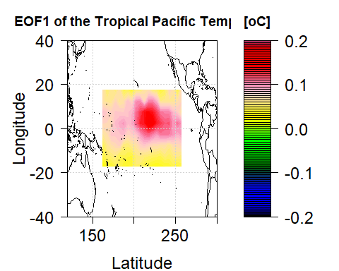

#Plot EOF2  
plot.new()  
u=U[,2]  
Lat=seq(-17.5,17.5, by=5)  
Lon=seq(162.5, 257.5, by=5)  
par(mar=c(4,5,3,0))  
mapmat=matrix(u, nrow=20)  
int=seq(-0.2,0.2,length.out=81)  
rgb.palette=colorRampPalette(c('black','blue', 'darkgreen',  
 'green', 'yellow','pink','red','maroon'), interpolate='spline')  
filled.contour(Lon, Lat, mapmat, color.palette=rgb.palette, levels=int,  
 xlim=c(120,300),ylim=c(-40,40),  
 plot.title=title(main="EOF2 of the Tropical Pacific Temp Data",  
 xlab="Latitude",ylab="Longitude", cex.lab=1.5),  
 plot.axes={axis(1, cex.axis=1.5); axis(2, cex.axis=1.5);  
 map('world2', add=TRUE);grid()},  
 key.title=title(main="[oC]"),  
 key.axes={axis(4, cex.axis=1.5)})

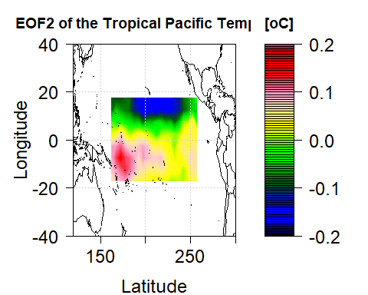

#Plot EOF3  
plot.new()  
u=U[,3]  
Lat=seq(-17.5,17.5, by=5)  
Lon=seq(162.5, 257.5, by=5)  
par(mar=c(4,5,3,0))  
mapmat=matrix(u, nrow=20)  
int=seq(-0.2,0.2,length.out=81)  
rgb.palette=colorRampPalette(c('black','blue', 'darkgreen',  
 'green', 'yellow','pink','red','maroon'),interpolate='spline')  
filled.contour(Lon, Lat, mapmat, color.palette=rgb.palette, levels=int,  
 xlim=c(120,300),ylim=c(-40,40),  
 plot.title=title(main="EOF3 of the Tropical Pacific Temp Data",  
 xlab="Latitude",ylab="Longitude", cex.lab=1.5),  
 plot.axes={axis(1, cex.axis=1.5); axis(2, cex.axis=1.5);  
 map('world2', add=TRUE);grid()},  
 key.title=title(main="[oC]"),  
 key.axes={axis(4, cex.axis=1.5)})

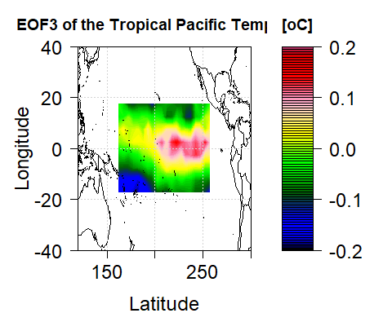

#(c) Plot three PCs V[,1:3]  
par(mar=c(4.5,4.5,2.5,1))  
time=1951:1999  
plot(time, V[,1], type="l", lwd=2,   
 xlab="Year", ylab="PC scale",  
 main="The first three PCs", ylim=c(-0.4,0.4))  
legend(1950,0.45, 'PC1',lwd=2, bty='n')  
lines(time, V[,2], type="l", lwd=2, col="blue")  
legend(1950,0.40, 'PC2',lwd=2, bty='n', col="blue")  
lines(time, V[,3], type="l", lwd=2, col="red")  
legend(1950,0.35, 'PC3',lwd=2, bty='n', col="red")

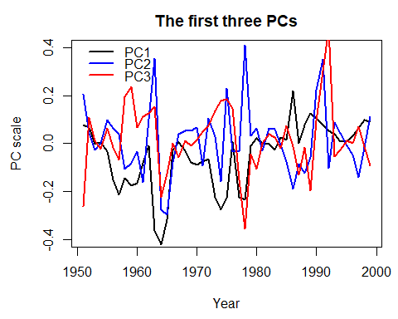

#5.9  
prcprecon <- read.csv("PrcpRecon5degAnn.csv")  
dim(prcprecon)

## [1] 2160 115

tropical <- which(prcprecon[,1]>-20&prcprecon[,1]<20&prcprecon[,2]>160&prcprecon[,2]<260)  
dim(prcprecon)

## [1] 2160 115

length(tropical)

## [1] 160

paccc = prcprecon[tropical, 0:50]  
paccc[paccc< -900.00] <- 0  
dim(paccc)

## [1] 160 50

SVDppp = svd(paccc)  
U = SVDppp$u  
D = SVDppp$d  
V = SVDppp$v  
  
D[1:10]

## [1] 2681.435600 145.135135 55.279292 28.795282 14.756982 11.525514  
## [7] 8.697461 7.638387 7.073056 5.890331

#5.9b  
paccc[,1]

## [1] -17.5 -12.5 -7.5 -2.5 2.5 7.5 12.5 17.5 -17.5 -12.5 -7.5 -2.5  
## [13] 2.5 7.5 12.5 17.5 -17.5 -12.5 -7.5 -2.5 2.5 7.5 12.5 17.5  
## [25] -17.5 -12.5 -7.5 -2.5 2.5 7.5 12.5 17.5 -17.5 -12.5 -7.5 -2.5  
## [37] 2.5 7.5 12.5 17.5 -17.5 -12.5 -7.5 -2.5 2.5 7.5 12.5 17.5  
## [49] -17.5 -12.5 -7.5 -2.5 2.5 7.5 12.5 17.5 -17.5 -12.5 -7.5 -2.5  
## [61] 2.5 7.5 12.5 17.5 -17.5 -12.5 -7.5 -2.5 2.5 7.5 12.5 17.5  
## [73] -17.5 -12.5 -7.5 -2.5 2.5 7.5 12.5 17.5 -17.5 -12.5 -7.5 -2.5  
## [85] 2.5 7.5 12.5 17.5 -17.5 -12.5 -7.5 -2.5 2.5 7.5 12.5 17.5  
## [97] -17.5 -12.5 -7.5 -2.5 2.5 7.5 12.5 17.5 -17.5 -12.5 -7.5 -2.5  
## [109] 2.5 7.5 12.5 17.5 -17.5 -12.5 -7.5 -2.5 2.5 7.5 12.5 17.5  
## [121] -17.5 -12.5 -7.5 -2.5 2.5 7.5 12.5 17.5 -17.5 -12.5 -7.5 -2.5  
## [133] 2.5 7.5 12.5 17.5 -17.5 -12.5 -7.5 -2.5 2.5 7.5 12.5 17.5  
## [145] -17.5 -12.5 -7.5 -2.5 2.5 7.5 12.5 17.5 -17.5 -12.5 -7.5 -2.5  
## [157] 2.5 7.5 12.5 17.5

paccc[,2]

## [1] 162.5 162.5 162.5 162.5 162.5 162.5 162.5 162.5 167.5 167.5 167.5 167.5  
## [13] 167.5 167.5 167.5 167.5 172.5 172.5 172.5 172.5 172.5 172.5 172.5 172.5  
## [25] 177.5 177.5 177.5 177.5 177.5 177.5 177.5 177.5 182.5 182.5 182.5 182.5  
## [37] 182.5 182.5 182.5 182.5 187.5 187.5 187.5 187.5 187.5 187.5 187.5 187.5  
## [49] 192.5 192.5 192.5 192.5 192.5 192.5 192.5 192.5 197.5 197.5 197.5 197.5  
## [61] 197.5 197.5 197.5 197.5 202.5 202.5 202.5 202.5 202.5 202.5 202.5 202.5  
## [73] 207.5 207.5 207.5 207.5 207.5 207.5 207.5 207.5 212.5 212.5 212.5 212.5  
## [85] 212.5 212.5 212.5 212.5 217.5 217.5 217.5 217.5 217.5 217.5 217.5 217.5  
## [97] 222.5 222.5 222.5 222.5 222.5 222.5 222.5 222.5 227.5 227.5 227.5 227.5  
## [109] 227.5 227.5 227.5 227.5 232.5 232.5 232.5 232.5 232.5 232.5 232.5 232.5  
## [121] 237.5 237.5 237.5 237.5 237.5 237.5 237.5 237.5 242.5 242.5 242.5 242.5  
## [133] 242.5 242.5 242.5 242.5 247.5 247.5 247.5 247.5 247.5 247.5 247.5 247.5  
## [145] 252.5 252.5 252.5 252.5 252.5 252.5 252.5 252.5 257.5 257.5 257.5 257.5  
## [157] 257.5 257.5 257.5 257.5

plot.new()  
u=U[,1]  
EOflatone = seq(-17.5,17.5, by=5)  
EOflongone = seq(162.5, 257.5, by=5)  
par(mar=c(4,5,3,0))  
matrixm = matrix(u, nrow=20, byrow=TRUE)  
matrixm=pmax(pmin(matrixm,0.3),-0.3)  
seqnum = seq(-0.3,0.3,length.out=75)  
rgb.palette=colorRampPalette(c('black','blue', 'darkgreen','green', 'yellow','pink','red','maroon'),interpolate='spline')  
filled.contour(EOflongone, EOflatone, matrixm, color.palette = rgb.palette, levels = seqnum,   
 plot.title = title(main="Annual tropical Pacific Precipitation Anomolies' EOF1", xlab ="Latitude",ylab ="Longitude", cex.lab=1.5, cex.main=.5),  
 plot.axes={axis(1, cex.axis=1.5); axis(2, cex.axis=1.5);grid()}, key.title=title(main="oC"), key.axes={axis(4, cex.axis=1.5)})

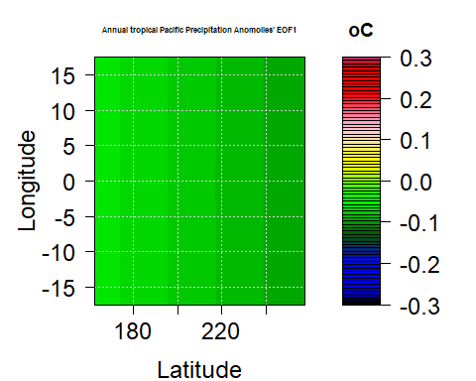

plot.new()  
u=U[,2]  
EOflatone = seq(-17.5,17.5, by=5)  
EOflongone = seq(162.5, 257.5, by=5)  
par(mar=c(4,5,3,0))  
matrixm = matrix(u, nrow=20, byrow=TRUE)  
matrixm=pmax(pmin(matrixm,0.3),-0.1)  
seqnum = seq(-0.3,0.3,length.out=75)  
rgb.palette=colorRampPalette(c('black','blue', 'darkgreen','green', 'yellow','pink','red','maroon'),interpolate='spline')  
filled.contour(EOflongone, EOflatone, matrixm, color.palette = rgb.palette, levels = seqnum,  
 plot.title = title(main="Annual tropical Pacific Precipitation Anomolies' EOF2", xlab ="Latitude", cex.main =.5,ylab ="Longitude",  
 cex.lab=1.5), plot.axes={axis(1, cex.axis=1.5); axis(2, cex.axis=1.5);grid()}, key.title=title(main="[oC]"), key.axes={axis(4, cex.axis=1.5)})

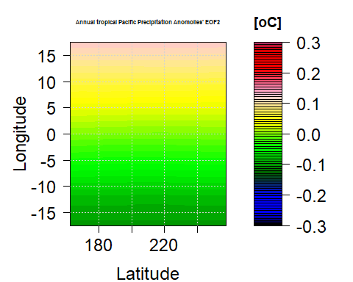

plot.new()  
u=U[,3]  
EOflatone = seq(-17.5,17.5, by=5)  
EOflongone = seq(162.5, 257.5, by=5)  
par(mar=c(4,5,3,0))  
matrixm = matrix(u, nrow=20, byrow=TRUE)  
matrixm=pmax(pmin(matrixm,0.1),-0.1)  
seqnum = seq(-0.3,0.3,length.out=75)  
rgb.palette=colorRampPalette(c('black','blue', 'darkgreen','green', 'yellow','pink','red','maroon'),interpolate='spline')  
filled.contour(EOflongone, EOflatone, matrixm, color.palette = rgb.palette, levels = seqnum, plot.title = title(main="Annual Tropical Pacific Precipitation Anomolies' EOF3", xlab ="Latitude",ylab ="Longitude", cex.lab=1.5, cex.main=.5)  
 , plot.axes={axis(1, cex.axis=1.5); axis(2, cex.axis=1.5);grid()}, key.title=title(main="[oC]"), key.axes={axis(4, cex.axis=1.5)})

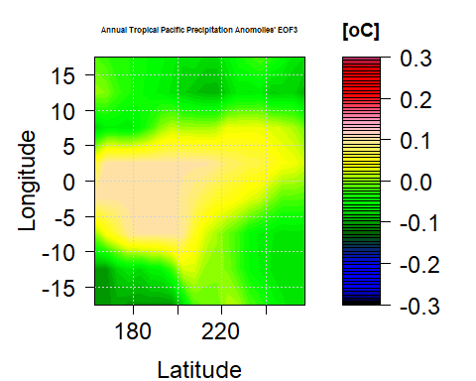

#5.9c  
par(mar=c(4,4,3,1))  
t <- seq(1951,2000)  
plot(t, V[,1], type="l", lwd=2, xlab="Year", ylab="PC Scale",main="First three PC (Principal Components) of Annual Tropical Pacific precipitation", ylim=c(-0.4,0.7), cex.main = .6)  
legend(1970,0.6, 'PC1',lwd=2, bty='n')  
lines(t, V[,2], type="l", lwd=2, col="blue")  
legend(1970, 0.5, 'PC2',lwd=2, bty='n', col="blue")  
lines(t, V[,3], type="l", lwd=2, col="red")  
legend(1970, 0.4, 'PC3',lwd=2, bty='n', col="red")

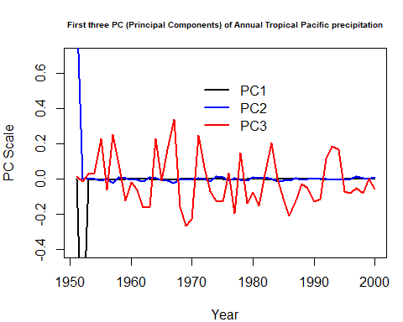

#8   
#note that length and d are 1  
numerator = 2  
pie = 3.14  
ps=numerator/pie  
ps

## [1] 0.6369427

#[1] 0.6369427  
  
  
#9  
N=100000  
nn=8  
x=matrix(runif(nn*N),ncol=nn)  
k=0  
for(i in 1:N){if((t(x[i,])%*%x[i,]) < 1) {k=k+1}}  
k

## [1] 1551

ex = (k/N)*2^nn  
ex

## [1] 3.97056

#4.07296 is volume.   
#The exact answer is 4.0587  
#can use the general formula also as seen below  
gen = pi^(nn/2)/gamma(nn/2 +1)  
gen

## [1] 4.058712

#10  
x=y=1:6  
n=100000  
v=0  
for (i in 1:n) {if(sample(x,1)+sample(y,1) == 7) v=v+1}  
v/n

## [1] 0.16528

# ran this code and got 0.16619 which is approximately 1/6.  
# code will give a different k/n each time but will be close to 1/6